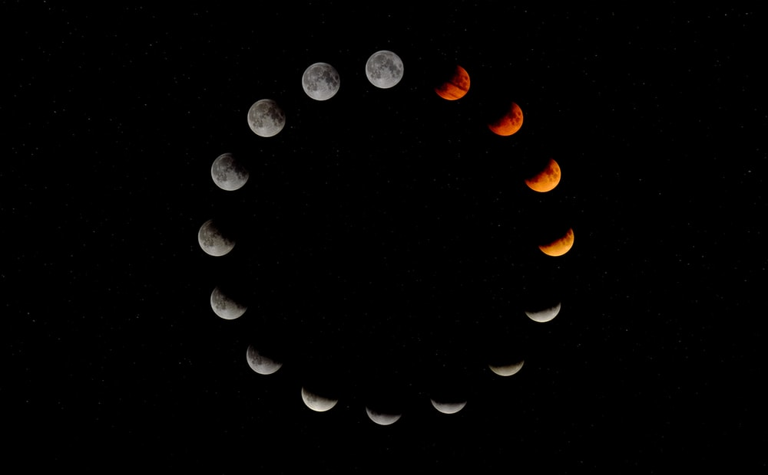

The KWHL chart is a thinking tool. It most useful for starting out on a topic. The KWHL helps you to jump start your thinking about your topic by determining:
- What you Know
- What you want to find out
- How you can learn more
- What you have Learned
Feeling stuck? Try filling out the KWHL!

The KWHL chart helps you ask essential questions for any research project:
- What do you already know that you can build on?
- What are you going to need to find out?
- How will you find out?
- What have you learned?

KWHL Chart
What do you already Know about your topic?
What do you Want to know about your topic?
How will you find information about your topic?
What did you Learn about your topic?

